DEVSECOPS

CLASS-1

Dev activities + Ops activities

Devops is not a particular tool or not a single software

DevOps is a set of rules or DevOps is a set of methodologies or it’s a process where combination of Developer and operations activities took place

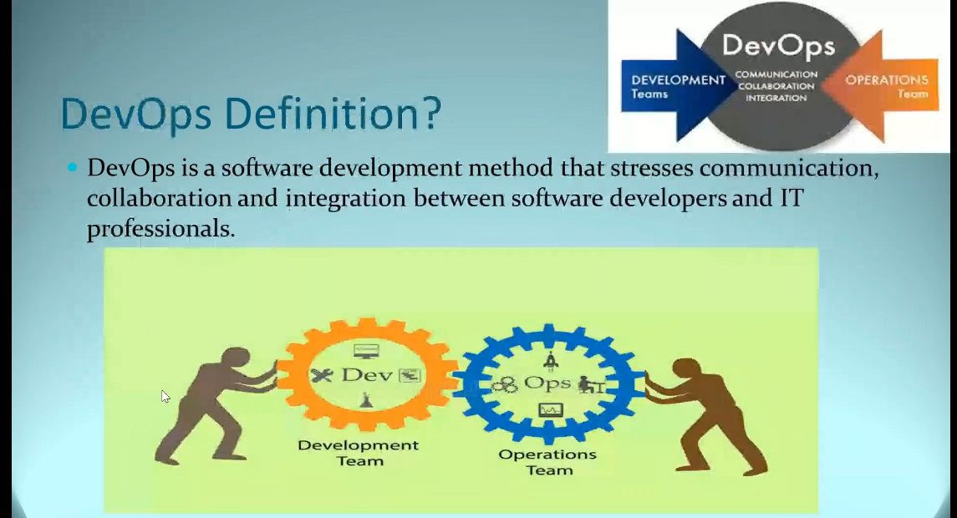

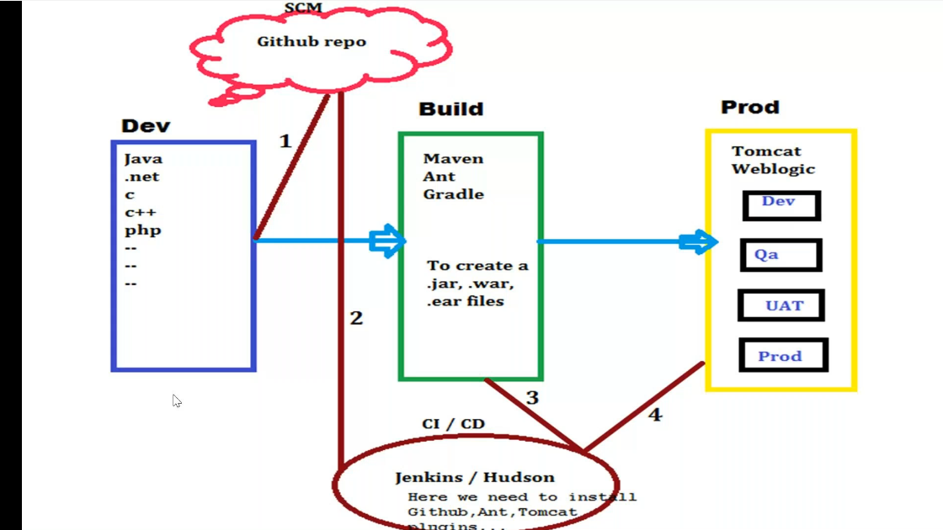

To create a website

Development team will implement code in their local machines{any language java .net c c++ etc., based on client requirement}

Sharing – Deveopers will share code through SCM repository

Source code management –{ Version control tools like git hub} – it is used so that we can monitor data and data changes and sharing safely

Build should be done

Now devops team will start working for building to generate executable file[.jar , .war , .ear etc.,]

We cannot deploy directly in production environment or live server

We deploy in various internal servers like Dev , Qa ,UAT, Prod . These environment may vary from organization to organization and may increase or decrease and Dev is mandatory

If we get any issue then testing team will report it to deveopers then again dev team will rectify it and upload new code and building will done and deployed in all environments

If everything is perfect then we deploy it in production environment

DevOps process will reduce the timegap between Dev and Ops team with CI/CD process

CI/CD tools – Jenkins/Hudson , Bamboo , codefresh

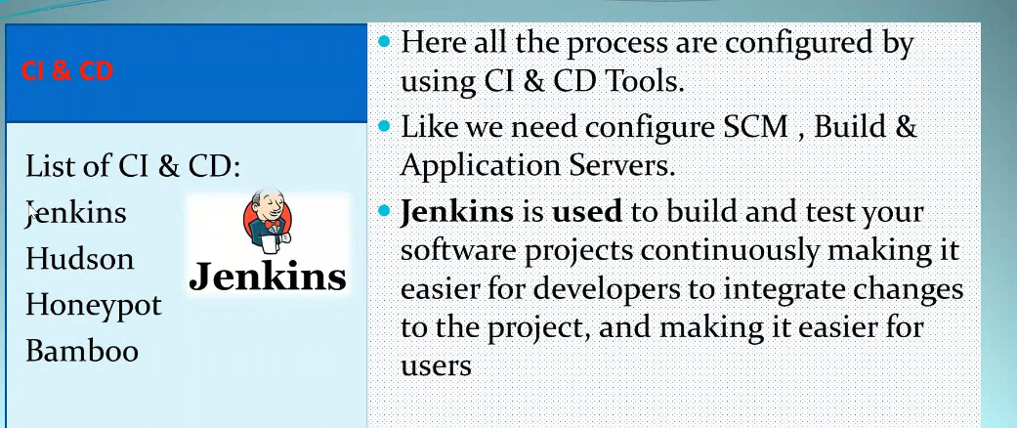

Jenkins is a plugin based tool- here we need to install Github, Ant , Tomcat plugins

Jenkins can connect and is integrated with morethan 4000 tools in the market

Here we install required plugins and configure them to create jobs [pipe lins or pre written instructions] like

* From which repo we have to take file
* When build process should be done
* Which build tool has to be used
* Which type of executive file has to be generated
* In which environment deployment has to be done etc..,

Suppose dev team modified code and uploaded in repositoty then the we can even create a pipeline to start the build process automatically

Jenkins will download code automatically and build it and create a executable file and deploy and start sanity process in all environments one by one

So we will save all the time

Hence DevOps is a software development method that stresses communication, collaboration and integration between software developers and IT professionals

We will connect with developers , testing team , infra team etc., to know where is the issue

Importance of DevOps –

* It’s a automated process
* Where each and every activity is a predefined with set of rules and regulations
* DevOps is important because it’s a software development and operations approach that enables faster development of new products and easier maintenance of existing deployments.
* Shorter development cycles, faster innovation
* Reduced deployment failures, Rollbacks and time to recover.
* Improved communication and collaboration
* Increased efficiencies
* Reduced costs and IT headcount

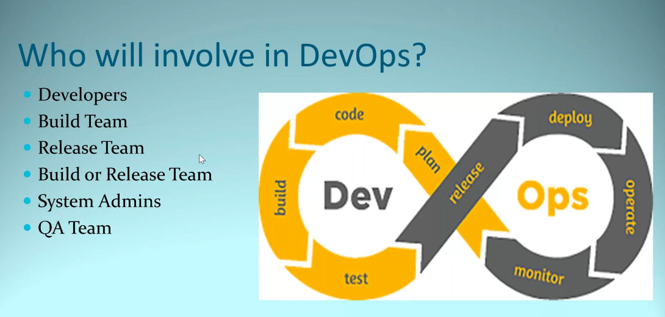

Build team /Build masters/Release team/Release engineers all are same

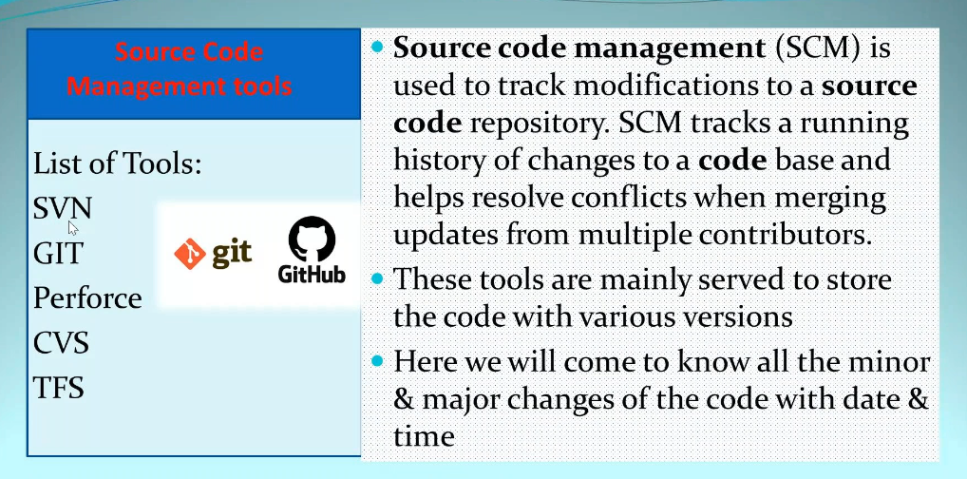

Git is most used and most important

Build tools—

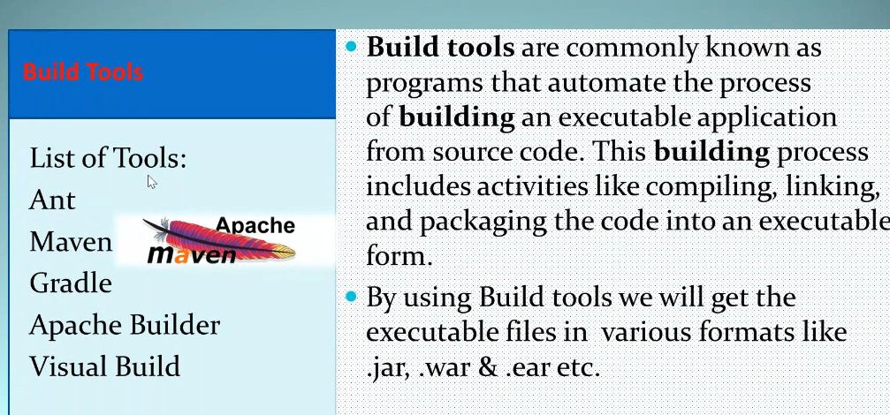

Application servers—

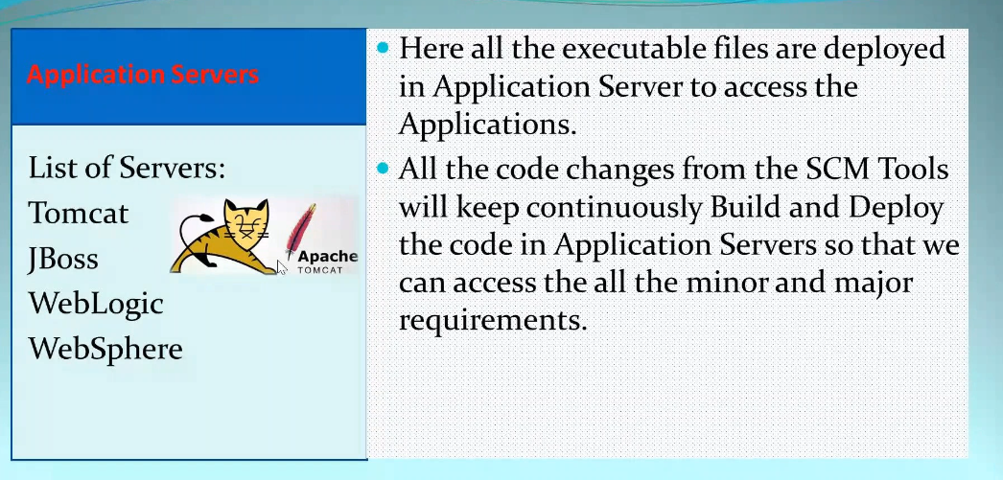

Supposer for windows we use mse , exe ,rpm are windows installable files and some are linux installable files. but incase some executable files like .jar .war etc., will be deployed in application servers like Tomcat

Deploy in production environment so that end users can access it and use it

DEVSECOPS—

Everywhere security is important.

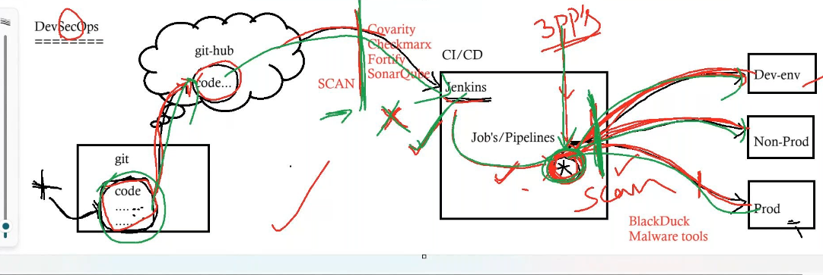

* Developers upload code in github

Code might leak and modified here somehow and uploaded in Git hub

Before Jenkins download it we will keep scans for security by using tools like covarity , checkmarx ,fortify , sonarQube etc.,

They will scan for vulnarabilities , bugs , dublicates etc., if perfect then allow for building if not it will reject and send reports to developer

* Jenkins will download and as per jobs created it will create a executable file

We will use some third party tools/open source libraries/public libraries called as 3pp’s for creating executable file. Suppose there might be any issue/vulnarability with outside files/3pp’s

Hence we will scan before deploying with tools like BlackDuck , Malware tools

\*LEFT SHIFT—Before we used to deploy in all environments and before deploying in production we will scan for issues but we shifted scanning before deployment in any environment

* Output file is deployed in all environments

Class -2

Configuration management tools

Suppose we have five servers and we can do the entire process of deployment in n number of servers by using cm tools and not only deployment we can do script changes , configuration changes ,user related , services , infra related activities etc..,

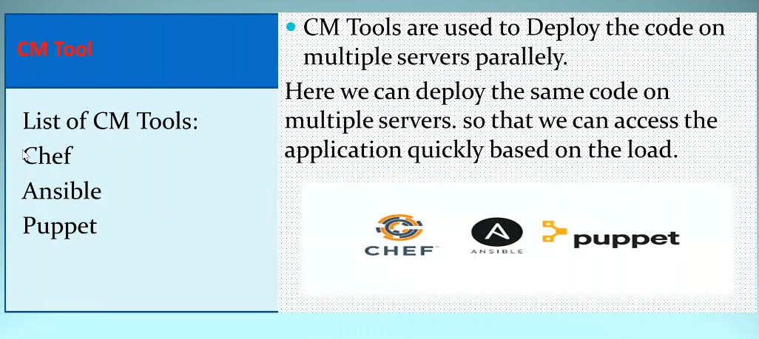

Chef architecture

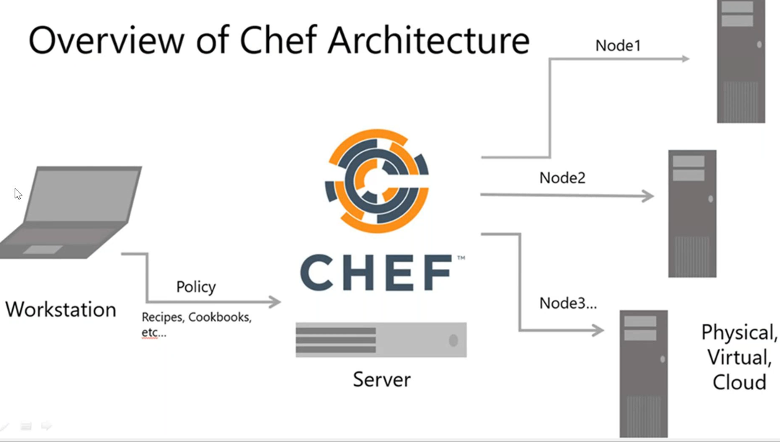

Suppose consider there are many servers

From workstation we will pass the instructions for the required activity and upload them to chef server and chef server has nodes connected to all the servers and we will add to the run list of the required servers to so that the activity will run on the required servers.

Virtualization and dockerization

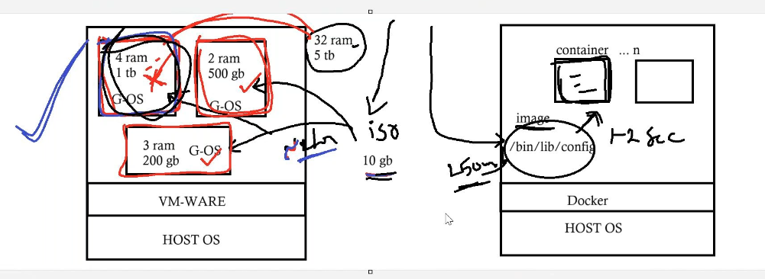

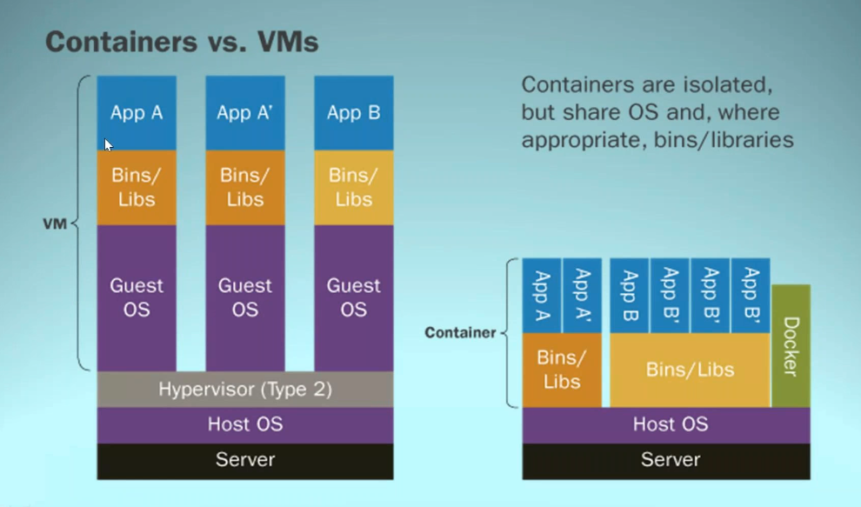

One physical server can be converted as many virtual servers

Any server need os for running called as host os

On top of it we install virtualization software like oracle and vmware so that we can split our resources in to n number of vms based on requirement we can allocate it

For each physical machine we need os so we use iso file to install os called as guest operating system which will take approx. 2 hrs

After installing guest os each machine will work as separate server

Challenges-

* Iso file size is 10gb and installation time is morethan 2 hrs
* Rebooting of each server is also time consumable(starting, restarting etc..,)

To check this Docker is introduced

Other than vm ware we install docker and we will have docker images

We can customize it and if no need we can use it as provided by docker community

This image contains all the binary files (/bin/lib/config)

Size of this image is 250mb and if we run this image we can create a container which will take lessthan 2 sec. where booting process is very fast

Containers

Suppose I want the same softwares in my machine to some other machines so I can create a docker image with required softwares and upload in docker hub so that can be moved easily to any number of machines. Once we download and run it we can access all the softwares and packages

So containers are isolated but shared os

Now a days we use docker in almost all environments

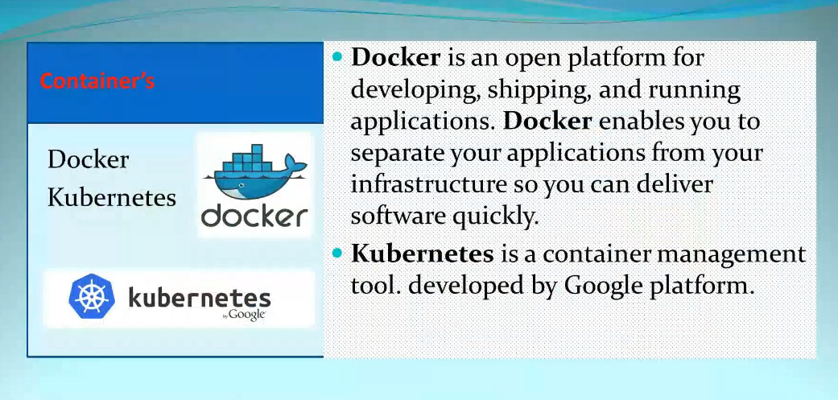

Difference between virtualization and docker

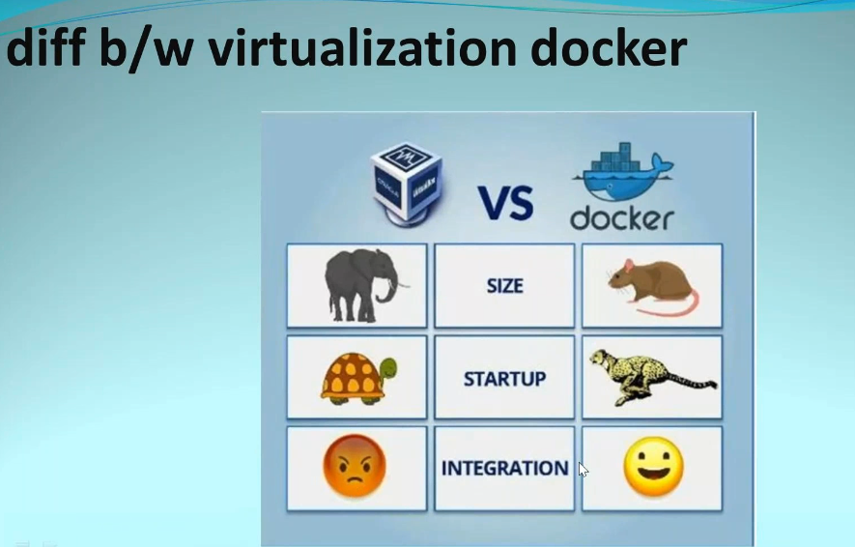

Container management tools

Kubernetes k8s , redhat open shift , docker swarm to manage containers

Cloud-

If we have a requirement of server with changing of usage based on various reasons. We need a source that provides unlimited resources and charges for used resources

There are various companies providing cloud like AWS , Azure , GCP etc..,

We can create n number of servers using cloud and if we don’t want we can reduce the usage by deleting the remaining servers. Charges will be based on time and quantity used

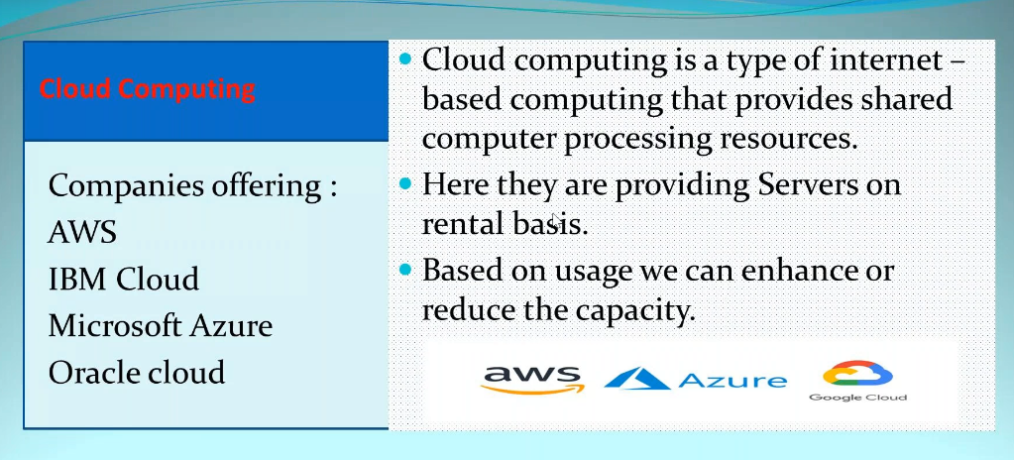

Terraform

It is a infrastructure automation tool. We can connect with all clouds and maintain them.